**Jenkins project**

*Done by Almaz Mullagilov*

It is a Jenkins pipeline project which pulls a Jenkins job from a GitHub repository. The Jenkins job describes deployment of a Docker container with Nginx pre-installed, copies index.html + Nginx config files into the created container and restarts Ngninx configuration. It results in one click deployment of an Nginx web server based on a Docker container as GitHub as source.  
  
GitHub repository:  
<https://github.com/btngithub/jenkins_job>Jenkins file:  
JenkinsFile2.txt

Jenkins job:

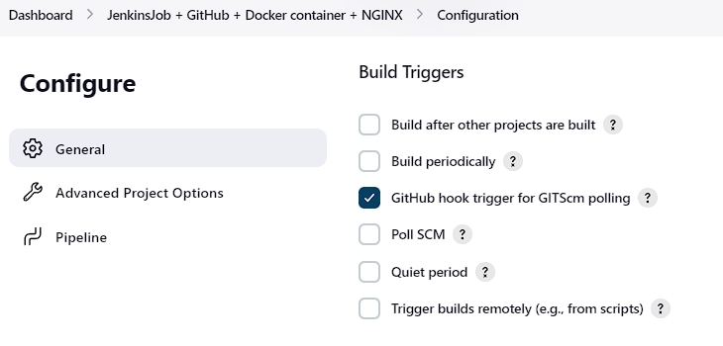  
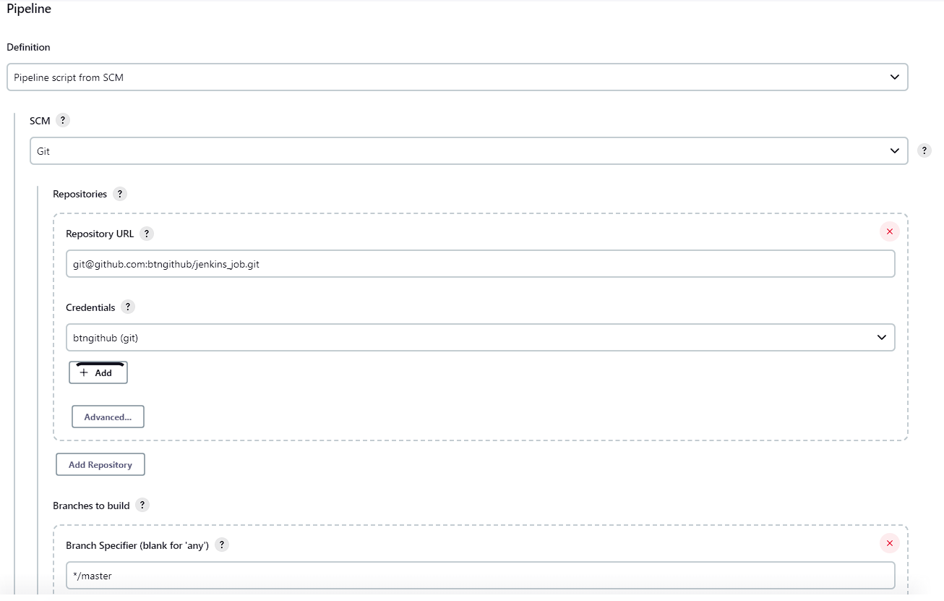  
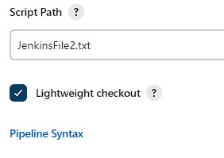

enkins file configuration (JenkinsFile2.txt) on the GitHub repository:  
  
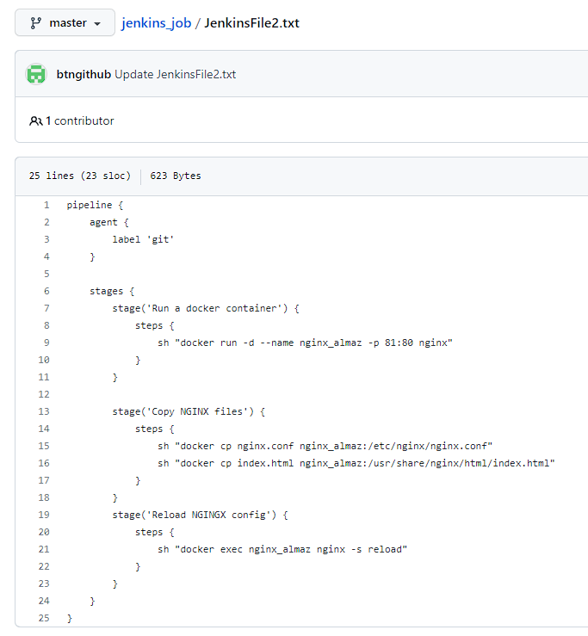

Job run results:  
  
  
Jenkins pipeline output:  
  
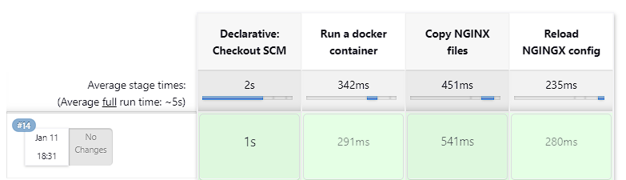  
Web server view:  
  
